# DEPARTMENT OF SCIENCE AND TECHNOLOGY

**CITIZEN COLLEGE, KUMARIPATI**



A Final Report on

**ONLINE LIBRARY MANAGEMENT SYSTEM**

A Report Submitted for the Partial Fulfillment of Requirements for The Degree of **Bachelor of Computer Application** in Sixth Semester

**Submitted By**

1. **Sebi Mahajan**
2. **Ashbel Ashish Lama**

**Date:2022/05/05**

# APPROVAL LETTER

The report entitled “**ONLINE LIBRARY MANAGEMENT SYSTEM**” submitted as a partial fulfillment for the requirements of Sixth Semester has been submitted by Ashbel Ashish Lama and Sebi Mahajan and are hereby recommended for approval and acceptance.

**Panel of Examiners:**

|  |  |
| --- | --- |
| **……………………..** | **………………………** |
| **Er. Nishan Khanal** | **Mr. Hari Krishna Aryal** |
| **(Program Coordinator)** | **(Principal)** |
|  |  |

**…………………….**

**External Examiner**

# ACKNOWLEDGEMENT

This project has been completed by Ashbel Ashish Lama and Sebi Mahajan with the help of Miss.Muna Bhusal and Mr.Bikas thapa. With their assistance and support, we wish to express them our sincerest gratitude. We would like to thank Miss.Muna Bhusal for guiding us throughout the project.

We also feel obliged and would like to prompt our gratitude towards our Principal Mr.Hari Krishna Aryal for allowing us to conduct a project on Online Library Management System. The mentioned project was done under the supervision of Mr.Nishan Khanal.

I feel thankful to the college staff for giving us an opportunity. I believe I will enroll in more such events in the coming future. We ensure that this project was done by us and is not copied.

**SEBI MAHAJAN**

**19530138**

**ASHBEL ASHISH LAMA**

**19530135**

# TABLE OF CONTENTS

DEPARTMENT OF SCIENCE AND TECHNOLOGY 1

APPROVAL LETTER i

ACKNOWLEDGEMENT ii

TABLE OF CONTENTS iii

LIST OF FIGURES v

LIST OF TABLES vi

CHAPTER 1: INTRODUCTION 1

1.1 Background 1

1.2 Motivation 1

1.3 Statement of Problems 2

1.4 Objectives 2

1.5 Scope 2

1.6 Limitations 3

CHAPTER 2: LITERATURE REVIEW 4

2.1 Introduction 4

2.2 A Look at Automation of Libraries in Institutions of Learning 5

2.3 Functionalities of Automated Library Systems 6

2.4 Challenges facing Automating Library’s in Kenya 7

CHAPTER 3: PROJECT MANAGEMENT 8

3.1 Team Members 8

3.2 Feasibility Study 8

3.2.1 System Feasibility 8

3.3 System Design 9

3.4 System Modules 9

CHAPTER 4: REQUIREMENT ANALYSIS 10

4.1 Functional Requirements 10

4.2 Non-Functional Requirements 11

CHAPTER 5: METHODOLOGY 13

5.1 System Architecture 13

5.2 Agile Development Methodology 14

5.2.1 Phases of Agile Model: 15

5.2.2 The Pros and Cons of Agile Modeling 15

5.3 DFD Diagram 17

5.3.1 Level 0 DFD (Context Diagram) 17

5.3.2 Level 1 DFD 18

5.4 Use-Case Diagram 20

5.5 Sequence Diagram 21

5.6 Entity-Relationship Diagram 22

CHAPTER 6: GANTT CHART 23

CHAPTER 7: TESTING 24

7.1 TEST EVIDENCES 24

CHAPTER 8: CONCLUSION 27

CHAPTER 9: FUTURE EXTENSIONS 28

REFERENCES 29

# LIST OF FIGURES

Figure 1: Agile Development Methodology 14

Figure 2: Level 0 DFD 17

Figure 3: Level 1 DFD (Student) 18

Figure 4: Level 1 DFD (Librarian) 19

Figure 5: Use-Case Diagram 20

Figure 6: Sequence Diagram 21

Figure 7: Entity-Relationship Diagram 22

Figure 8: User Registration Form 24

Figure 9: Registration Successful 25

Figure 10: User Profile 25

Figure 11: List of Books 26

# LIST OF TABLES

Table 1: GANTT Chart 23

# CHAPTER 1: INTRODUCTION

## 1.1 Background

Information Technology has revolutionized the lives of human beings and has made the lives easier by the use of various kinds of applications and contraptions. In the light of the rapid changes with the use of IT (Information Technology), there are many tools, technologies and systems which have been produced and invented. In the modern world, time is limited likewise many progressions take place at a time, hence a need for integration of all the processes, creation of paperless environment ensures efficient task management.

A library is a place where a huge collection of books and resources are available which can be accessible by the users. It acts as a brain for the institutions. It enhances the distribution of knowledge among the students. The tons of books and research works are captivating the students to improve their knowledge in all perspectives. It guides the students to promote their views differently. This knowledge optimizes the student to achieve a better result in academic as well as personal skill development.

Nowadays all the businesses are shifting to computer-based system. The purpose to having a computer-based system is, it helps to increase the productivity and it’s very easy for customers to use while being time efficient. It is increasing the demand among the customer. This project is concerned with developing a “Online Library Management System”. In this system the library management becomes more efficient & easier to handle with its reliable system components.

The project “Online Library Management System” is a library management system for monitoring and controlling the transactions in a library. It is a project which aims in developing a computerized system to maintain all the daily work that occurs in a library. This project is developed in PHP, which mainly focuses on basic operations in a library like adding new member, new books and updating new information, searching books and members to borrow and return books.

Our college whilst having a library is still a traditional one where most of the works are manual and is a tedious work. As the first batch of BCA, we would like to advance the working condition in our library by introducing “Online Library Management System”.

## 1.2 Motivation

A college without a library is like a footballer without football. Online Library Management System focuses on improving efficiency and simplicity by providing a more comfort of work in the library. As we are the first batch of our college, I personally think it is our duty to show inspiration to our juniors.

## 1.3 Statement of Problems

Many libraries are operated manually by a group of people. These people keep records regarding the books and students (borrowers), checks the books manually and keep records on issued books. All these things have to be carried out manually and if the library is very large, proper record keeping will become a major problem as manual record keeping has never been a reliable method because people tend to forget things.

Other problems of the existing system are:

1. It is difficult to trace a book
2. Information about issue/return of the books is not properly maintained
3. No central database can be created as information is not available in database

The manual system poses a number of challenges which include:

1. It consumes (wastes) a lot of time.
2. It is difficult to process large volumes of information concerning books.
3. It has no backup for the records hence in case of any exposure to danger, all information is prone to be lost.
4. It requires a lot of paper work hence more room and staff is needed to handle them which translates to more costs; making the system expensive.
5. It’s difficult to search where a book is sectioned in the library and its availability.

## 1.4 Objectives

The goal of coming up with this system was to design, develop, and implement a fully automated Online Library Book Management System. The objectives of this project are:

1. To build an online system that keeps track of books in the library
2. To make an online book issue in Citizen College
3. To make an effortless work for the librarian as well as the students
4. To place a computerized system to maintain all the daily work of library

## 1.5 Scope

The scope of this project is also the range or ambition of this work, which information is needed, the way the proposed system is used, the available technology, willingness on the part of college to change from the existing system to the new and some of this point will be fully explained in the subsequent chapter of the project.

The proposed system will cover the various kind of operation in the library system, some of the areas which the system will cover are:

1. Library
2. User log-in page
3. Student information page assessment
4. Book Register

## 1.6 Limitations

The library management system as being designed is specifically designed to shorten the work in our college library. But not all the needed facts are available due to the following reasons:

1. Unwillingness on the part of library personnel especially the librarian consulted for the needed information.
2. The duration assigned for the project is very small.
3. Due to not enough motivation from instructors. A sense of responsibility to be lost.

# CHAPTER 2: LITERATURE REVIEW

## 2.1 Introduction

This chapter reviews information about the Library Management Systems that have already been researched and developed together with the various approaches used by these systems. Online journals, articles, publications and books were used to provide information on this topic. Libraries across the world present a conducive environment where people converge to do their research and study. Majority of these libraries are situated within the facilities of learning institution. These libraries play an important role in the entire operation of an institution. (Chweh S.S, 1981) In his journal titled “User criteria for evaluation of library service” outlined features of a good library. These include: Availability of periodicals, good collection of reference material, non-book materials and books, and the quality of reference services delivered, quite environment for studying, catalog integrity, how services are friendly and willingness of librarians to help. The Library Book Management System has been developed with the aim of improving services delivered to its users. This is made possible by automating all the library services. The system was developed after evaluating the legacy system which had not automated a majority of its functions. User requirements were gathered so as to determine the relevant functionality that was needed. This evaluation acted as a management tool to measure the effectiveness of services delivered to the library users and to identify disadvantages of the system and the most appropriate way forward. Book lending systems were created way back in the past centuries even before the computer age. The French book wheel invention enabled scholars to circulate books by stepping on a pedal that turned a book table. Albert Cotgreave developed the book indicator back in 1863. It housed smaller versions of the books making it possible to tell the availability of the book, or if it was overdue. Automation of libraries began in 1930’s. This is when the punch card systems were used to manage book acquisition and circulation. (Gapen, 1993) Notes; virtual library comprises aspect of remotely accessing services and content of other libraries, alongside other resources of information. The internet acts as a powerful tool through which materials can be made available for sharing and access by anyone across the globe. Libraries have accumulated resources that can provide a good source of information for research and other use. Making these rich resources available to the general public across the globe is of great advantage. The aim of technological advancements is to make work easier and ensure efficiency is realized in all facets of life where it’s applicable.

(Aswal, 2006) Notes; that library automation is the process of interconnecting systems to enable the sharing of information through networks hence providing access to large volumes of content and information to users across the globe. The use of the internet and networking has been emphasized a lot. A library needs the latest technology been used in the 21 centuries, hence, institutions need to phase out legacy systems, and embrace automation of all their services. (Johnson, Houda, & Tony., 2004) Note that a virtual library can connect e-learners to online public library catalogues, resource rich databases which are licensed and electronic books, materials for research and learning. These virtual libraries allow users to access them around the globe and at any time so long as they are connected to the internet. The adoption of the Library Book Management System poses great benefits to the end users since the system aims at delivering automated services efficiently and effectively via the internet.

## 2.2 A Look at Automation of Libraries in Institutions of Learning

Over the past years, library management systems have been under rapid development. These online libraries are flexible because they offer a 24hrs access, and operate 7day a week, and 365 days a year. These library systems enable easy searching of material hence saving time. They enable information that was only available to a few individuals accessible to everyone. They also help in preserving material that could otherwise wear off. Original documents are translated into digital formats and archived in databases. (Roberts, 1999) A Librarian at Cohen Hillel Academy points out that after automating their library services; the electronic catalogue was faster, versatile, and easier to use than the old card catalog which they used before automation. The new system encouraged both students and teachers to do more research by utilizing the resources offered. The librarian notes that the school library had only automated their circulation functions which made use of older circulation software. They used this program till 1998 when they decided to upgrade to the Follett Software Company’s Circulation Plus and Catalog which was computerized. She notes that to motivate the library staff their workload must be simplified and the technology been used by the school streamlined. This system had a number of advantages:

1. It increased interest in the library and enabled easy access to resources. This helped both the students and staff to find electronic resources more easily.
2. It presented a user-friendly technology; whereby the windows platform was easy to use with less training required. Location of material became easier and it was done promptly.
3. Reports were generated easily hence presenting library staff with the opportunity to manage library operations effectively.
4. The system presented a consistent learning environment and ease of maintenance.

A majority of libraries in Kenya are found in research centers, private and public institutions of learning. Public universities have the highest volumes of books, journals, research papers, and other collections. The libraries were set up with the main aim of been used by both the students, teachers, lecturers and staff members within the institution. There has been a collected effort by the library management to restructure their services so as to extend them to other outsiders other than the normal users. Many of the libraries are coming up with information resource centers in the spirit of embracing technology. (Amollo, 2011) Highlighted the relevance of digitizing libraries as:

1. It improves and widens access to electronic collections done by other digital libraries.
2. It enhances the lifetime of information material.
3. It encourages and facilitates sharing of resources amongst libraries across the world.
4. It reduces duplication of work.

(Amollo, 2011) Points out a number of initiatives aimed at digitizing libraries in Kenya. One of these initiatives is the Greenstone digital library software which was engineered by UNESCO back in 2008, and held at University of Nairobi (UoN). In 2007, Electronic Information for Libraries teamed up with the Koha Foundation to develop expertise and to grow the network for Greenstone which is a suite of software for building and distributing digital library collection in South Africa.

This foundation was extended back in 2009 to involve sixteen countries including Kenya. There are three designated National Centers in Kenya which were established to play a key role organizing training events and supporting trainees who are undertaking digitization projects or building Greenstone digital library applications. Such initiatives are aimed at expanding the information technology world to be incorporated in the libraries so as to make academic resources available to everyone across the world. Library Book Management System is an online system, which enables its users to access it round the clock. It has an added functionality for users to feel they are part of the system by displaying their profile on login and enabling them to update their details.

## 2.3 Functionalities of Automated Library Systems

A good number of Library Management Systems suppliers have come together with the aim of integrating a number of functionalities. These include:

1. The inter library loan modules, incorporated in the circulation system.
2. Online Public Access Catalogs providing search functionality.
3. Incorporating resource management software and reading list within OPACs.
4. Sending users reminders on reservations by using integrated computer telephony.
5. Serials check-in using Electronic Packing Slip.
6. The use of Radio Frequency Identification technology for checking stock. The use of RFID tags to track library material.

(Felstead, 2004) Points out functionalities developed by a number of Library Managements Systems developers. They comprise of:

1. Developing digital solutions aimed at managing libraries.
2. Development of portal programs with the aim of offering users a centralized place to search resources at ago.
3. Use of Open URL technology that offer links to reference materials and other useful resources.
4. Development of electronic resource managing solutions that control licensing and subscription of information and resources respectively.

## 2.4 Challenges facing Automating Library’s in Kenya

Libraries in Kenya are faced with a number of challenges when it comes to automating the library services. Some of these reasons include:

1. Lack of sufficient funds to support the entire automation process.
2. Lack of facilities to run the automated software program.
3. Lack of the man power with adequate skills to handle the systems.
4. (Otando, 2011) Highlighted a number of problems encountered in the development of institutional repositories. They include: inadequate staffing and lack of technical experts for the systems, limited support from high institution managements levels, lack of sensitization, low funding for the systems, and non-prioritization institutional repositories within library systems. These issues can be solved if institutions observe the points mentioned above accordingly.
5. A review of literature reveals that a computerized library management system will:
6. Help to improve the library services.
7. Help the Liberians with management information.
8. Help the librarian in reporting on the various operations of the library.
9. Increase the rate at which Tasks are completed accurately
10. Obviate the need to hire additional staff with increased demand for services.

Nwalo (2003) posited that a computerized library management system involves the use of a computer application on computers in library. A number of studies have reported on the application of information technology in libraries in Nigeria. These reports include that of Lawani, Azubike and Ibekwe (1992), Mosuro (1996), Idowu and Mabawonku (1999), Ogunleye (1997) Agboola (2000), and Ajala (2001) Nok (2006). All of these studies have agreed that serious application of information technology to library processes started in Nigerian libraries in the early 1990s.

# 

# CHAPTER 3: PROJECT MANAGEMENT

## 3.1 Team Members

Our team comprises of two individuals, Sebi Mahajan and Ashbel Ashish Lama. We managed our project by dividing work to complete our project by deadline.

## 3.2 Feasibility Study

## 3.2.1 System Feasibility

A system undergoes a number of feasibility analyses to ascertain if it can be acquired and eventually adopted. It involves a continuous process that looks at the operational, technical, economic, cultural, legal, and schedule feasibility of a system among other factors.

1. Operational Feasibility

Operational feasibility evaluates whether a system is relevant to operate in a particular environment. Library Book Management System presents a number of features making it operationally feasible.

The system is easy to use and navigate hence enables any user with minimal computer skills to use it. The system has incorporated the use of security features and access levels that allow only authorized users to login. The system is navigable since it presents users with a number of options to click on and accomplish their functions. It presents an easier way to capture user input for eventual processing. End users don’t need to have technical skills to use the system.

1. Technical Feasibility

The system is technically feasible in a number of ways. It was developed using a number of readily available web development tools. Coding was done using PHP server-side scripting language, JavaScript, Bootstrap, CSS, and HTML5. The system made use of MySQL and APACHE database and XAMPP Server which are open source and cross platform independent.

1. Cultural Feasibility

Cultural feasibility takes a look at the feelings of the system end users. A number of issues raised by the end users were put into consideration while designing this system. The system is culturally feasible in a number of ways. End users can access the system and view their profiles using their respective unique passwords and usernames.

The system has functionality for users to change their passwords. The users have come to appreciate the system due to its attractive and user-friendly nature. The system grants more access privileges to the librarian unlike other users of the system due to his administrative nature of tasks.

1. Economic Feasibility

This feasibility looks at the costs incurred in operating the system versus the revenue and accumulated returns. Library Book Management Systems is economically feasible in the sense that; it’s cheaper to acquire, it saves on the cost spend on paper since it operates automatically, the number of employees needed to operate the system is reduced hence lowering labor costs, and it saves time by facilitating quicker services to the end users.

1. Legal Feasibility

This system has minimal licensing issues since it was developed using open-source software. This system is meant to operate in the library, hence it’s subject to the rules and regulations governing the institution.

1. Schedule Feasibility

Refer to; Appendix 1 a. Schedule of Project Activities to view the Gantt and Perl chart.

## 3.3 System Design

System Specification

|  |  |
| --- | --- |
| Hardware Specification | Software Specification |
| Processor: Intel Pentium IV and Above. | Operating System : Windows 10 (X64) |
| Ram: At Least 4Gb | Language : PHP |
| Hard Disk: At Least 80 Gb | Database : MySQL 5.3 |
| Monitor: 14 Inch Color Monitor. | Server : XAMPP Server |
| Processor: 3.0 Ghz Processor | Browser : Brave, Google Chrome |
| Peripheral’s: Mouse and Keyboard |  |

## 3.4 System Modules

Library Book Management System is separated into two modules. Each module has an interface within which a number of functions are enabled. The system has access rights to control access to the modules.

1. Student Module

This module captures username and password for student. It records all the student’s database and the books that they took.

1. Librarian Module

When a librarian has to take control of the system and its members, whether it be adding new students or new books or removing a student. Librarian module takes control of all those.

# CHAPTER 4: REQUIREMENT ANALYSIS

## 4.1 Functional Requirements

The system has a number of functions which include:

1. The system shall enable the librarian to create a new user using the Add User functionality. The system shall assign users a unique username and password which allows them to access the system. The system shall enable the librarian to display all the users using the List Users functionality. The system shall enable the librarian to update or delete a user’s details. The system shall enable all users to change their passwords using the Change Password functionality. If a user forgets his/her password, the system shall enable the librarian to reset and issue them new passwords using the Update User functionality.
2. The system shall enable the librarian to update a member’s information using the Update Member functionality. This information comprises of all the member’s details.
3. The system shall enable the librarian to add a member card. This enables the necessary information concerning the member to be captured in order to process their respective cards. The system shall enable the librarian to update, display, and search or delete the member’s card information from the system.
4. The system shall enable the librarian to display all the members registered to the system using the List Member functionality. The system shall enable the librarian to delete, update, and search a member.
5. The system shall enable the librarian to add new books to the system using the Add Book functionality where he captures all the book details into the system. The system shall enable the librarian to list, delete, update, and search a book using the List Books, Delete Book, Update Book, and Search Book functionalities respectively. The system shall enable the librarian to view damaged books, lost books, overdue books, and returned books using their respective functionalities in the system.
6. The system shall enable the librarian to add new authors to the system using the Add Author functionality where he captures all the authors’ details into the system. The system shall enable the librarian to list, delete, update, and search an author.
7. The system shall enable the librarian to add publishers to the system.
8. The system shall enable the librarian to view member fines and print a receipt for the member.
9. The system shall enable the librarian to list and respond to the visitor’s feedback using the Manage feedback functionality. The system shall enable the librarian to delete and update the feedback using the respective functionalities.
10. The system shall enable the librarian to change his/her password using the Change Password functionality.
11. The system shall enable users to view and update their profile using the Profile and Update Profile functionalities respectively.
12. The system shall enable a member to display and search books using the Display Book and Search Book functionalities.
13. The system shall enable a member to file a complaint using the File Complaint function.
14. The system shall enable a member to change his/her own password using the Change Password functionality.

## 4.2 Non-Functional Requirements

1. Security

Secure access of confidential data (user’s details). SSL can be used. The system has incorporated the aspect of sanitizing user input to prevent possible hacking by passing any variables received from the $_POST and $_GET arrays.

The system has incorporated the use of HTML entities function to prevent HTML injection, Cross Site Scripting (XSS) and to ensure user’s privacy and protection. This function prevents malicious users from inputting java script code that could display itself on the systems website. It also prevents the malicious users from stealing cookies from the system users which might disclose crucial information like passwords and usernames.

1. Performance
2. Response Time:

The respond time to a user should be within one to two seconds from the request time.

1. Throughout

The LBMS shall enable many users to access it concurrently. The volume of transactions will depend directly on the number of users.

1. Utilization of Resources

The LBMS shall make use of a MySQL database that can handle close to 5000 records. The system resources shall be modified in accordance with user requirements.

1. Reliability

The LBMS shall operate 99% of the time. This system has to be reliable due to the important role it plays, and the crucial data it handles.

1. Accuracy

The LBMS accuracy is determined by the speed of use executed by its users.

1. Access Reliability

The LBMS shall provide access reliability of 99.9%.

1. Availability

The LBRM shall be 100% available to all the users. The users shall be able to use it 24hrs a day, and 365 days a year. This system shall operate 24hrs a day and 7days a week.

1. Portability

The LBMS has been developed and coded using PHP scripts. These scripts run on a windows environment via the XAMPP Server. The codes can be moved from this environment to other platforms like UNIX and Mac OS supporting other servers like IIS, Apache with PHP scripts and ODBC modules installed.

1. Usability

The LBMS has a user-friendly interface which is self-explanatory and easy to use. It supports any web browser as an interface making it easily accessible and usable. It requires no specific training on the user’s part. Any kind of errors have been handled using a number of formats.

1. Friendliness

The LBMS’s has a simple look and feel with highly contrasting colors.

1. Privacy

The LBMS user privacy has to be secured and protected.

1. Extensibility

The LBMS should be expanded in the future to handle more users and books.

# CHAPTER 5: METHODOLOGY

## 5.1 System Architecture

The Library Book Management System makes use of a Layered Architecture. Architectural designs have to incorporate the concept of independence and separation. This allows any changes taking place to be localized. A layered architecture applies this notion of independence and separation. The systems functionality is organized and divided into separate layers. Each layer depends on the services offered by the immediate layer beneath it. The system was developed incrementally allowing users to access some services provided by the layers as they underwent development. This architecture is also portable and it can be changed easily. This systems architecture is divided into a number of layers including the web browser, user interface, core functionality, and the operating system/database.

1. Operating System, Servers and Database Layer

This layer comprises of the database and operating system which basically acts as the support software for the Library Management System. This system can run on any operating system including Window, Linux, and Mac OS. It makes use of MySQL database running on XAMPP Server. PHP server-side scripting language was used to code the system.

1. Core functionality Layer

This layer houses:

1. The application layer which has all the application functionality.
2. The data access layer which facilitates access to the MySQL database.
3. User Interface Layer

This layer contains the user interface management. It incorporates the login functionality that authenticates and verifies the system users.

1. Web Interface Layer

This layer contains the various web browser applications that provide an interface between the clients and the inner layer.

## 5.2 Agile Development Methodology

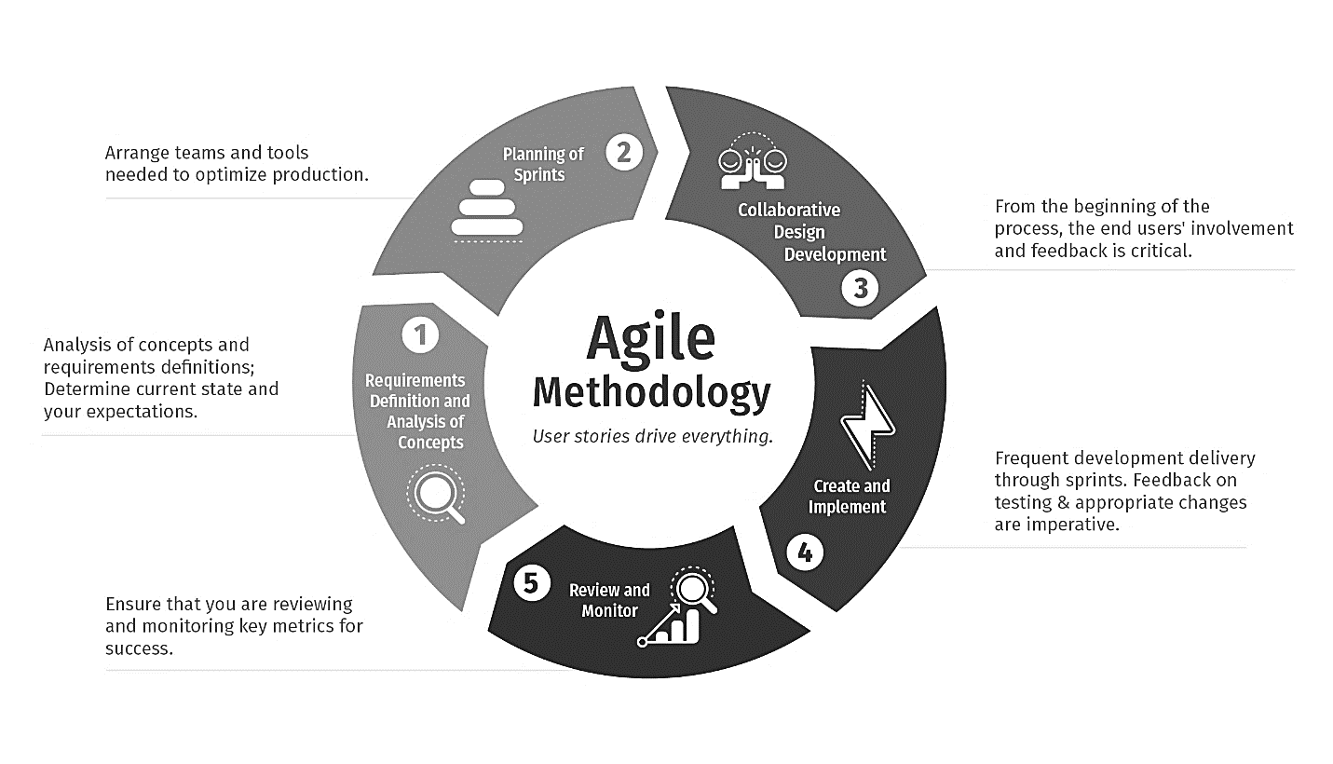

Figure : Agile Development Methodology

"Agile process model" refers to a software development approach based on iterative development. Agile methods break tasks into smaller iterations, or parts do not directly involve long term planning. The project scope and requirements are laid down at the beginning of the development process. Plans regarding the number of iterations, the duration and the scope of each iteration are clearly defined in advance.

Each iteration is considered as a short time "frame" in the Agile process model, which typically lasts from one to four weeks. The division of the entire project into smaller parts helps to minimize the project risk and to reduce the overall project delivery time requirements. Each iteration involves a team working through a full software development life cycle including planning, requirements analysis, design, coding, and testing before a working product is demonstrated to the client.

## 5.2.1 Phases of Agile Model:

Following are the phases in the Agile model:

1. Requirements gathering
2. Design the requirements
3. Construction/ iteration
4. Testing/ Quality assurance
5. Deployment
6. Feedback
7. Requirements gathering:

Defining the requirements for the project falls under requirement gathering. Planning the time and effort is necessary.

1. Design the Requirements:

Once you’ve identified the project parameters, work with the stakeholders to define the requirements.

1. Construction/Iteration:

After the team defines and designs the requirements, the real work begins. Product, design, and developer teams start working on related projects, ultimately deploying a product or service that is not static.

1. Testing:

The quality assurance (QA) team examines and evaluates the product's performance, looking for bugs and other flaws.

1. Deployment:

The team deploys the product in a working environment.

1. Feedback:

Once the product is released, the team receives feedback about the product and handles any issues that may have arisen.

## 5.2.2 The Pros and Cons of Agile Modeling

The modeling brings advantages and disadvantages to the table.

1. Advantages
2. Facilitates effective communication between teams and clients
3. Enhances project flexibility, easily handling sudden changes anytime
4. Cuts overall development time
5. Increases customer satisfaction via rapid, continuous delivery of a workable product
6. Delivers functioning software frequently, in weeks instead of months
7. Disadvantages
8. Confusion between teams may develop because documentation wasn’t emphasized. This uncertainty can lead to difficult transitions between phases.
9. It is sometimes difficult to gauge how much effort will be needed to start the development life cycle of larger software deliverables.
10. If stakeholders project ladder is not on the same page, the project will derail.
11. The modeling isn’t for newbies. The sort of decisions involved in Agile require people with experience and solid developer and programming skills.

## 5.3 DFD Diagram

A DFD diagram or Data Flow Diagram is traditional way of showing how the information flows within a system. It can depict a good amount of the system requirements graphically. It can be done manually, automated or a combination of both.

The Data Flow Diagram (DFD) represents the flow of data and the transformations in the library management system. These transformations occur as data enters and exits a system. In the DFD, input, processing, and output are used to represent and define the overall system.

It shows how information enters and leaves the system, what changes the information and where that information is stored. The purpose of DFD is to show the scope and boundaries of the system as a whole.

DFD diagram usually begins with a context diagram as a level 0 of the DFD diagram which shows a simple representation of the whole diagram. To further elaborate that, level 1 diagram with lower-level functions that are decomposed from the major functions of the system. If further analysis is needed, then level 2 diagram is made.

## 5.3.1 Level 0 DFD (Context Diagram)

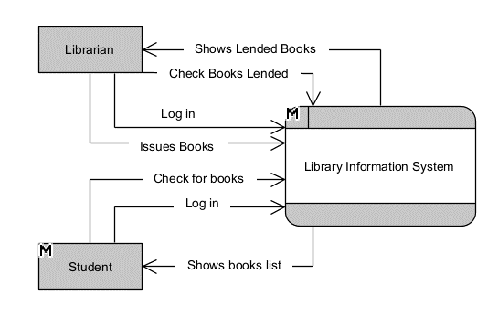

Figure : Level 0 DFD

What is Library Management System DFD level 0?

A context diagram is another name for it. It depicts the overall structure as a single bubble with incoming/outgoing indicators showing input and output data. The data flow diagram level 0 also considers the entire system to be a single process and emphasizes the system’s interaction with external entities. Context diagrams (level 0 DFDs) are diagrams in which the entire system is represented as a single process. A single process node and its connections to external entities are depicted in Level 0 data flow diagrams.

## 5.3.2 Level 1 DFD

5.3.2.1 Student

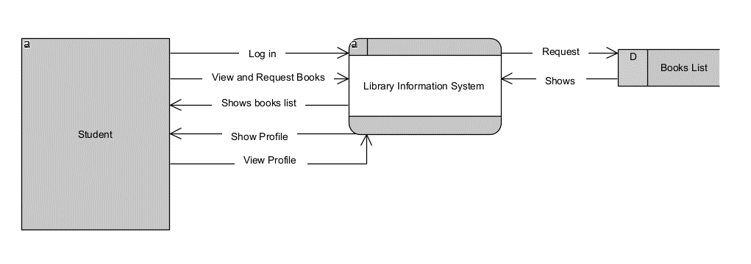

Figure : Level 1 DFD (Student)

What does a Library Management System level 1 DFD entail?

Level 1 DFDs provide a broad overview but go into greater depth than a context diagram. The single process node from the context diagram is broken down into sub-processes in a level 1 data flow diagram. The above level 1 DFD shows relationship of Student with the Library Management System.

5.3.2.2 Librarian

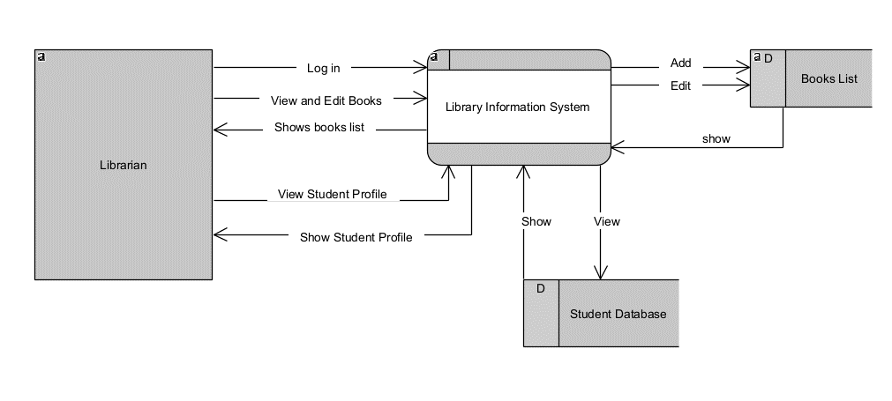

Figure : Level 1 DFD (Librarian)

In the Fig above, entails the relationship between Librarian the Library Management System. It shows the process, in which the librarian can check students’ profile, check what books are lent, and the amount of time period is left. It also shows what books are contained in the library and what books need to be added.

A librarian staff can issue a book to members and these details stored in the data store. He/she can display issued books whose details are retrieved from the data store. The librarian staff can return a book, which had been borrowed by a member, to the system; these details are stored in the data store.

## 5.4 Use-Case Diagram

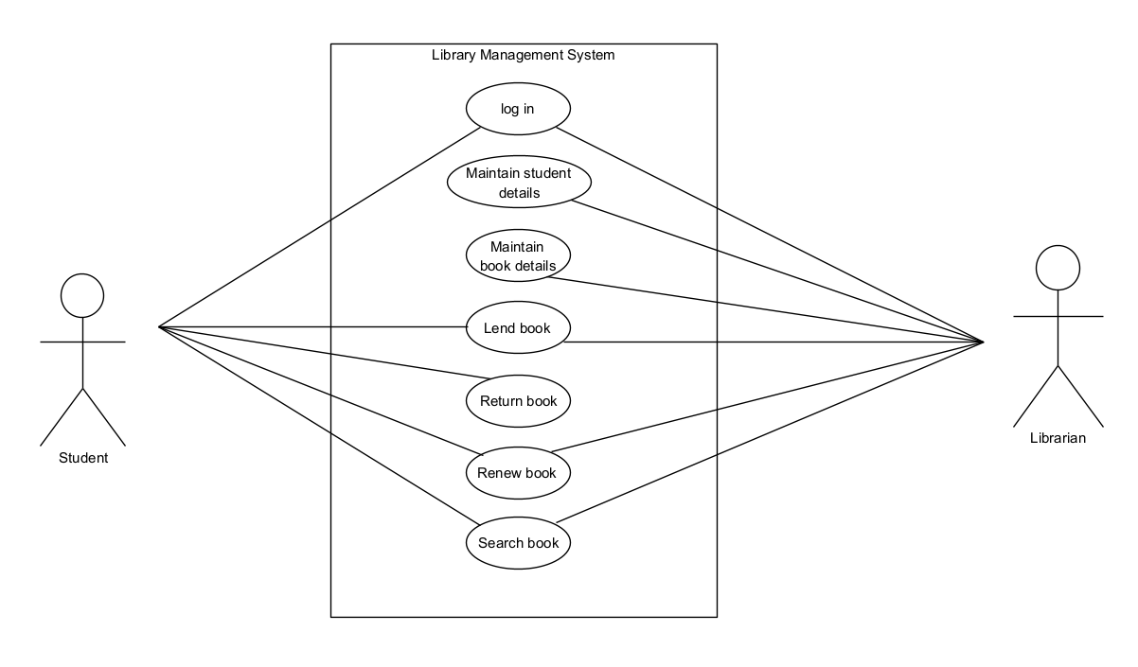

Figure : Use-Case Diagram

## 5.5 Sequence Diagram

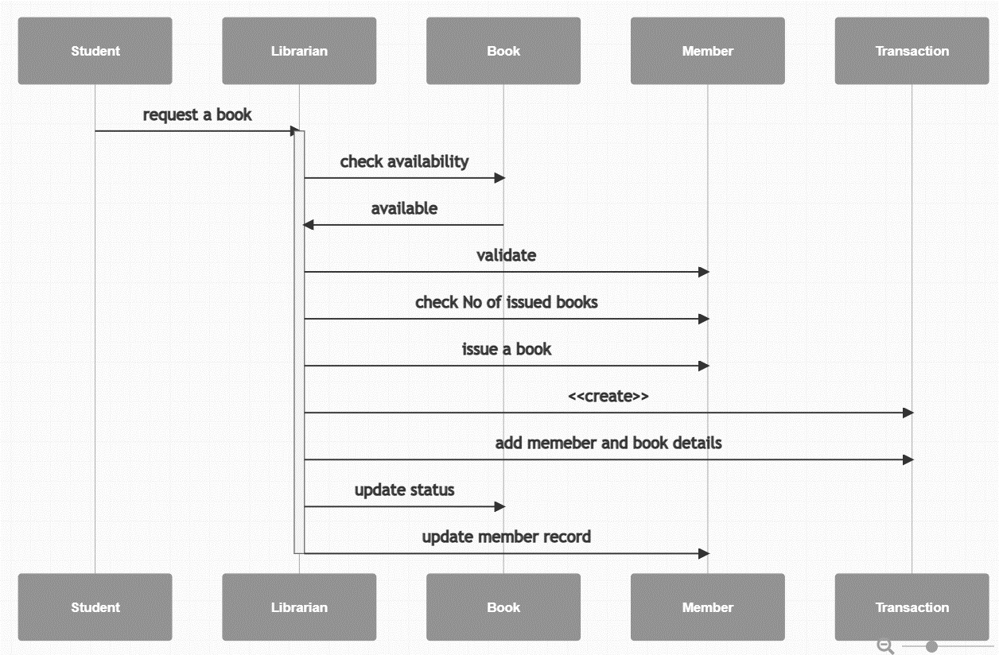

Figure : Sequence Diagram

**Process:**

* Student requests book from Librarian
* Librarian checks the book
* If the book is available, msg is sent back
* Librarian validates if the student is eligible
* Librarian checks the number of books issued
* Librarian issues the book once validation is complete
* Librarian sends a create message to transaction
* Librarian sends the students member to the book for later use
* Librarian updates for book status
* Librarian updates students record

## 5.6 Entity-Relationship Diagram

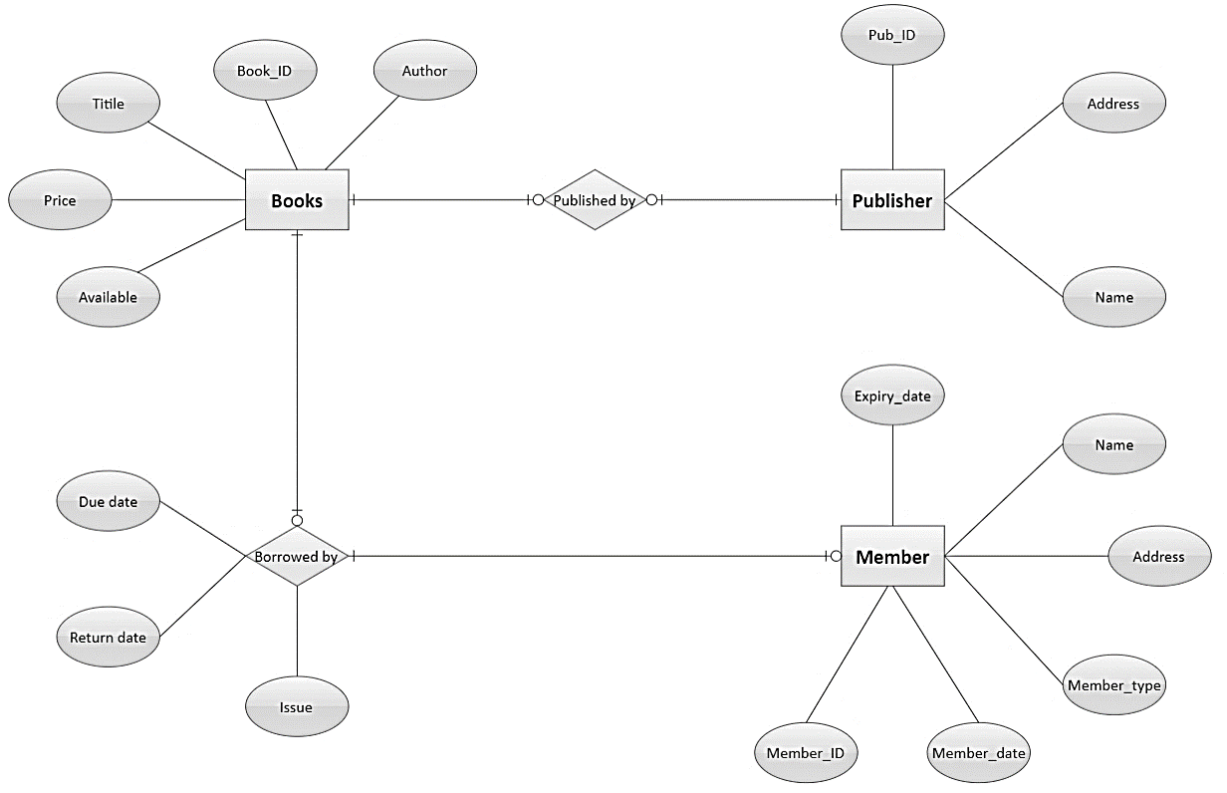

Figure : Entity-Relationship Diagram

This example depicts the ER diagram for library management system which involves various entities and Attribute likes books, publisher, member etc. An entity relationship diagram (ERD), also defined as an entity relationship model, is a graphical depiction of relationships between people, things, locations, concepts, or events in an information technology (IT) system. An ERD employs data modeling approaches to assist in the definition of business processes and as the foundation for a relational database. Entity relationship diagrams serve as a visual starting point for database architecture and may also be used to assist establish information system requirements throughout an organization.

# CHAPTER 6: GANTT CHART

A Gantt chart is a project management tool that illustrates a project plan. It typically includes two sections: the left side outlines a list of tasks, while the right side has a timeline with schedule bars that visualize work. The Gantt chart can also include the start and end dates of tasks, milestones, dependencies between tasks, and assignees. To keep up with the demands of modern software development, roadmap tools like Jira Software include features like a collapsible task structure and resource management panels. These roadmap tools help teams maintain a coherent project strategy despite the iterative nature of the software development process.

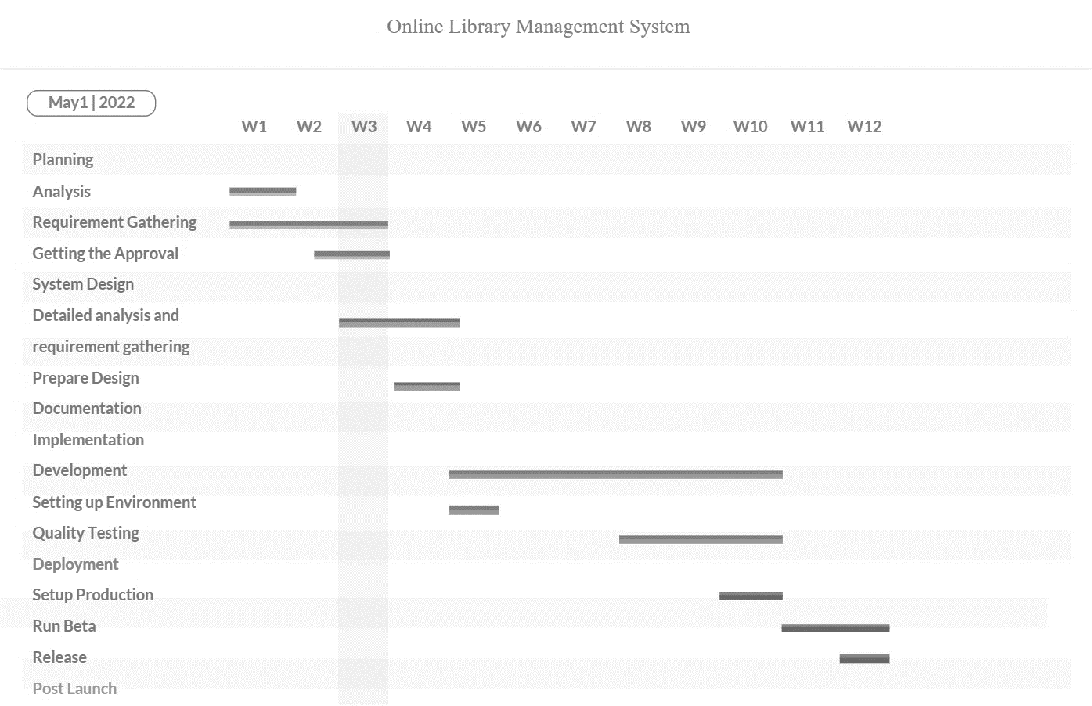

Table : GANTT Chart

# CHAPTER 7: TESTING

Testing is as important as the coding phase itself. Without a proper test of the system, one cannot determine if their system is in fact functional or not. It is important to ensure that the system meets the requirements. We need to evaluate our system to make sure that the system works as intended.

## 7.1 TEST EVIDENCES

TEST 5.1.1

Test: login

Purpose: Check sign up page and execute sign up

Outcome: Proper sign up of a student is done

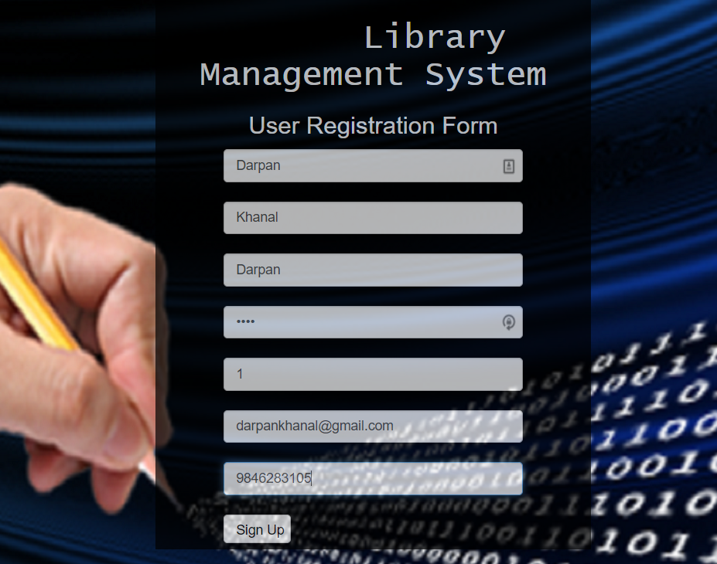

Figure : User Registration Form

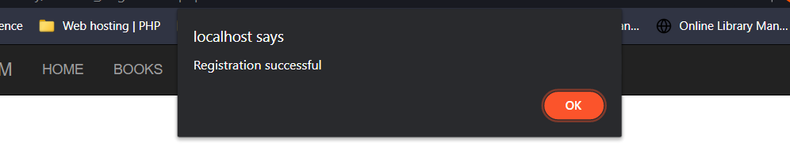

Figure : Registration Successful

TEST 5.1.2

Test: Registration

Purpose: Check sign in of the previous sign up

Outcome: Proper sign in is executed

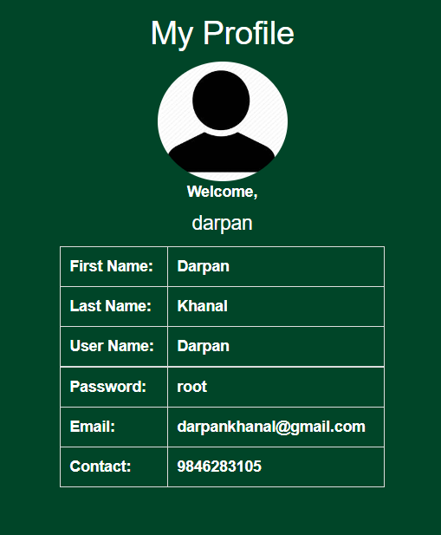

Figure : User Profile

TEST 5.1.3

Test: Book

Purpose: Check books that are issued

Outcome: Book issued are available

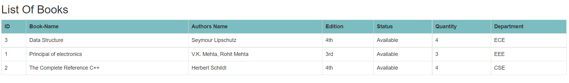

Figure : List of Books

# CHAPTER 8: CONCLUSION

This chapter covers the system tests and results. This are demonstrated using a number of screen shots. Library Book Management System aimed at accomplishing a number of tasks. The system met its accomplishments and the following section looks at these tasks and how they are accomplished.

LBMS has been designed and developed with high security standards. A number of security levels have been designed to limit privileges according to a user type. Users can access a page depending on the security levels given to them. These levels determine the various rights and operations a user can carry out on the system. The levels include; the librarian access levels and the members access levels.

The availability of new technology has enabled automation of nearly all services provided in any facet of life. The library is not an exception to this great idea; hence it comes with a good number of advantages when all the activities that take place in it are automated. New jobs will always be created as a result of automation. Staff will always be motivated to work with new automated systems, since a lot of paper work is eliminated, and functions and services are concentrated just within the power of a mouse click and input of data into the system. Costs are incurred only once; when buying the system, and training personnel. Users have the convenience of accessing the system from the comfort of their locations since its web based. Cost benefit analysis of the system also shows that it generates more revenue than expenses hence the system is economically feasible.

# CHAPTER 9: FUTURE EXTENSIONS

We can further develop more systems into the Library Management System. We can add more extensions in this project as demanded by an individual or necessity. We can make the system more reliable. The Same system can be extended to perform the function of receiving and sending feedbacks. Adding the functionality of calculating fine and providing detailed reports. Some of the future extensions that will be made are as follows:

* Adding the functionality of calculating fine
* Adding the functionality of making detailed reports
* Adding the functionality of receiving and sending feedbacks

# REFERENCES

* [1] Aggarwal, K.K., & Singh, Y. (2007). Software Engineering (3rd Ed.). New Age International Publishers.
* [2] Amollo, B. A. (2011). “Digitization for libraries in Kenya”.

2nd International Conference on African Digital Libraries and Archives. URL:http://www.slideshare.net/bamollo/digitization-forlibraries-in-kenya

* [3] Alison Felstead. (2004). “Library systems marketplace: a digest of current literature” Program: electronic library and information systems.
* [4] Chweh, S. S. (1982). “User criteria for evaluation of library service”. Journal of Library Administration, 2(1), 35-46.
* [5] Gapen, D. K. (1993). “The virtual library: Knowledge, society and the librarian.” In The Virtual Library: Visions and Realities, edited by L. M. Saunders, pp.1-14. Information Today, Medford, NJ.
* [6] IEEE Standards 1016-1998, Recommended Practice for Software Design Descriptions
* [7] IEEE Standards 830-1998, IEEE Recommended Practice for Software Requirements Specifications.